Instructions for the authors of the papers
Name and surname*
* Name of the institution represented by the author written using 9 pt size fonts.
Abstract: Name of the institution represented by the author written using 9 pt size fonts. Before the text of the paper a short abstract (optimum: 10–15 type lines) shall be provided. The abstract shall be written on a width of 13 cm, shifted by 0.5 cm from left margin (first type line with 0.5 cm indention) using 9 pt size Times New Roman CE fonts; interline distance: min.11 pt size. The abstract shall synthetically present the issues discussed in the paper – analysed data, test methodology and the most important results of the studies.
Keywords: optimum: 2–5 in 1-3 lines, fonts: Times New Roman CE (9 pt size, Italic)
1. Text of the publication
Scientific works in the scope of mining, geology, geotechnical and geological engineering and related sciences are published in "Mining Science". Problematic aspects comprise following topics: application of fundamental science to mining, technology of deposit excavation in underground and strip mining, shooting technique, mine engineering and construction, underground construction, mining geomechanics and geotechnics, mine ventilation and geotechnics, fluid mechanics and its application to mining, mineral processing, environmental protection and waste recycling. The works in the scope of geological engineering and science at the boundaries of mining, civil engineering, geotechnics, geographic information systems and Earth science are also published in "Mining Science".
The publisher kindly asks to format the delivered materials in accordance with the instructions specified herein. The text shall be written in Word using Times New Roman CE fonts and e-mailed or submitted on data carrier (CD-Rom, USB flash drive) in form of a digital file. This manual may be used as a template to prepare publication. For this purpose, respective portions of this document shall be replaced with the passages of the publication being prepared.
The sizes of the column (printed area without page number) shall be 13.5 × 19 cm; size of margins: side – 3.7 cm, top – 5 cm and bottom – 5.7 cm.
Centered title of the publication shall be written using capital letters - font size: 15 pt, bold. A distance of 30 pt size shall be left before and after the title; interline distance shall be of 17 pt size.
Main text shall be printed using 11 pt size fonts and interline distance of 13 pt size. Whole width of the area for printing shall be used. 0.5 cm indentions shall be observed. No blank type lines shall be left between indentions. When formatting the text avoid to leave single letters (i, o, w, z) at the ends of the type lines and indentions in the first and last line of a page.
The titles of sections and sub-sections shall be printed using standard, bold fonts of 13 and 11 pt size, respectively. A distance of 24 and 18 pt size shall be left before and after section titles, and 13 pt size interline distance shall be observed. In case of sub-section titles these values shall be of 18, 14 and 11 pt size, respectively.
The length of the text along with graphical attachments, tables and bibliography shall not exceed 12 pages formatted in accordance with the foregoing instructions.
The submission of the paper to publish will be deemed the Author(s) declares the presented contents are original and have not been published so far in any other publishing house and he/she/they give consent to publish the paper in e-form on public domain servers. The paper author(s) shall submit the following statements:
- of original nature of the paper contents and copyrights thereto
- of author's contribution to create the paper
- of financing sources (or they shall provide information of financing sources in acknowledgement section)
- of copyright transfer onto the magazine/ publisher.
2. Illustration – figures, maps, and images
Illustrations included in the delivered papers may be in form of figures, maps and/ or images. They shall be consecutively numbered – e.g. Fig. 1, Fig. 2, etc. Cross-references to individual illustrations shall be provided in the text (nevertheless, they only supplement the paper contents).
2.1. Preparation of illustrations
Only black & white illustrations shall be comprised in publication. They shall be prepared in PC graphic editor or attached in form of black-white (lineart) or of grey scale scan. Colour illustrations will be converted to appropriate format, however, the publisher does not guarantee proper print-out quality. Irrespective of the illustrations integrated with the text (in Word file), separate files with illustrations in original formats (e.g. cdr, eps, tif or jpg) shall be also submitted. The size of individual file shall not exceed 3 MB. In case of vector files (e.g. cdr) change of the fonts into Italic is recommended. Illustrations prepared in CorelDraw shall be saved in software version not higher than CorelDraw 11.
Care shall be taken to assure the illustrations are clear and understandable. A linear scale, and in case of a map, indication of North direction shall be indicated on the illustrations; if required, the images shall be provided with orientation of sight field (e.g.: N–S, NW–SE).
2.2. Captions of illustrations
The illustrations shall be provided with brief description in Polish and English underneath. 9 pt size straight fonts shall be used. 12 pt size interline distance shall be observed, and 6 pt size distance before and after the caption shall be left. One blank line shall be left below illustration.
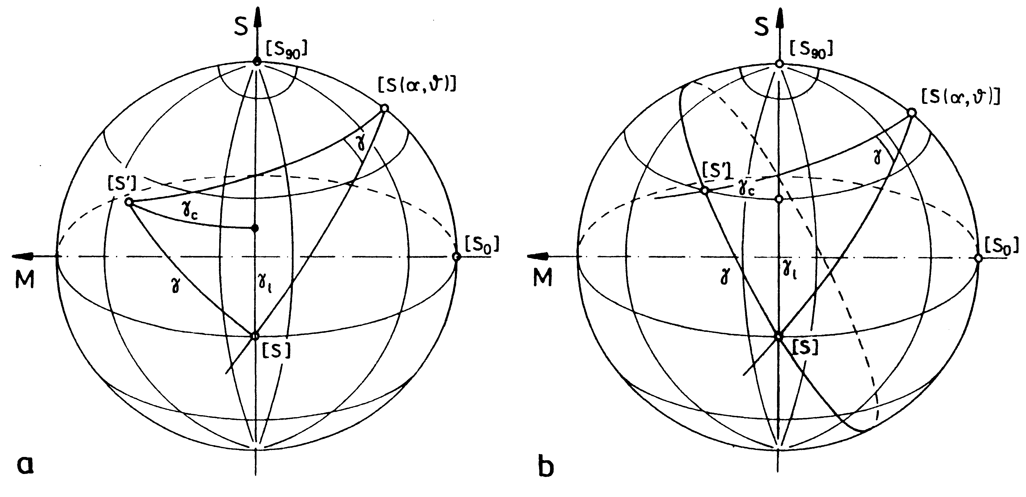
Fig. 1. Illustration caption (Ikeya-Seki, 1998)
If necessary, cross-references to respective literature sources shall be quoted in the captions (see sec. 4).
3. Tables and formulae
Tables formatted in Word and integrated with the text may be included in the paper. The table size may not exceed the size of one printed page. Text in the table shall be written using 10 pt size fonts (or the smaller ones, subject to the data amount). Synthetic captions (in Polish and English) shall be provided above the tables. Table caption format shall be analogous to the format of illustration captions. Tables shall be numbered with consecutive Arabic numbers (Tab. 1, Tab. 2, etc.). One blank line shall be left below the tables.
Tab. Table caption
Provinces | Elements
Provinces | tons | % | tons | % | tons | %
Dolnośląskie | 2854676 | 99.5 | 1263062 | 58.5 | 85203 | 19.1
Lubelskie | 378665 | 98.6 | 1802 | 8.8 | 39856 | 80.1
Lubuskie | 105272 | 97.7 | – | – | – | –
Łódzkie | 3015731 | 99.8 | 203329 | 60.2 | 23 | 0.0
Małopolskie | 1256989 | 99.3 | 101452 | 64.8 | 6892 | 21.1
Mazowieckie | 1356118 | 99.2 | 36669 | 19.1 | 860 | 1.7
Opolskie | 2416327 | 99.8 | 69232 | 84.2 | 3578 | 12.9
Podkarpackie | 267321 | 98.8 | 177 | 1.2 | 158 | 2.4
Podlaskie | 116765 | 98.5 | 1029 | 17.6 | 44 | 1.3
Pomorskie | 282625 | 98.8 | 2127 | 8.2 | 78 | 0.9
Explanations of non-standard symbols, abbreviations, etc. used in the table may be provided below the table (written using 9 pt size fonts).

Formulae shall be written using 11 pt size fonts. They shall be centered and identified with consecutive numbers in round brackets shifted to the right margin. Variable symbols shall be written in Italic. Round brackets shall be used in formulae instead of slashes. Ranges of values shall be written without spaces e.g. 700–1300 tons.
$x=\frac{a^{1−c}+b}{\text{10}−d_{2}}$ (1)
4. Quotation of literature sources
and formatting of RefeRences list
Cross-references to literature sources (books, papers in magazines, documentation) in paper text shall be provided in round brackets with indication of author's name followed by comma and year of publishing – e.g. (Nizioł, 1988). Papers written by two authors shall be cross-referenced with indication of both names (Paszczak & Grzyb, 2003); in case of many authors – the name of first author followed by "et al." shall be quoted. (Jabloncova et al., 1952). No endnotes shall be used in the papers. Patents shall be quoted in the following manner: the name(s) and surname(s) of the inventor(s) (quoted in the same manner as for cross-references to the papers – i.e. name(s) followed by comma and year) or the name of the company (if inventor name(s) are not specified). Identification of a standard shall comprise complete standard number (i.e. all numerals and letters) and year of standard implementation (recommended). Maps, plans, atlases - (Beskid Sądecki i Żywiecki, 1985)
Structure of bibliography reference of: a government regulation (type of legal act, date of entry into effect); of an act (J.o.L.2008.115.728).

Bibliography list (designated as " Bibliography") shall be prepared in alphabetic order. It should comprise only the sources cross-referenced in the text. In description of individual publications following information shall be provided: full names and surname initials of all authors, full title of the paper (possibly with the number of issue or volume), the title of the magazine, in which the paper was published along with the number (of bulletin, volume) or the name of the publisher, the place and the year of publication and the number (s) of page (s) (in case of papers published in magazines). Patents shall be quoted in the following manner: the name(s) and surname(s) of the inventor(s) (quoted in the same manner as for cross-references to the papers – i.e. the name(s) of inventors followed by comma and year) or the name of the company (if inventor name(s) are not specified) and indication of the patent country – e.g.: US patent: patent ID-number preceded by international code of the country shall be quoted. Identification of a standard shall comprise complete standard number (i.e. all numerals and letters comprised in ID-code of the standard) and the title of the standard (including superscription and subtitle). Quoting the year of standard implementation (if it is not an integral part of standard ID-number) is recommended.
Structure of bibliography reference of: a government regulation (title of the act, date of entry into effect). The title of the legal act, Art…. sec.…. item.…. let… /sec./sub-sec.…, an act (Act of 12th March 2004) or (J.o.L., year of issue)

Maps, plans, atlases. A cartographer shall be deemed the author of a map for the purpose of bibliography reference. Maps, plans and atlases published separately shall be quoted in the same manner as concise publications b. maps and plans included in a concise or continuous publication shall be quoted in the same manner as the papers in concise or continuous publications. A mandatory component is indication of the type of a document (map, plan, atlas,...) if it is not included in its title. In description of a map, its scale shall be quoted after the title and supplements to the title.
Addresses of websites with brief explanations may be quoted in the bibliography list.
5. CONCLUSION

ACKNOWLEDGEMENTS

In this place, the Editor requires the authors of publications to disclose the information of publi-cation's financing sources. The paper is the effect of the scientific project no…….
REFERENCES
Beskid Sądecki i Żywiecki, 1985. Map. 1 : 1000 000. Issue 10. Warszawa 1985. ISBN 83-0222-43.
J.o.L.[year of issue].[no].[item]
Eder U., Wiechert R., Sauer G., Title, German patent, DE 2 014 757, October 7, 1971.
Finckh L., 1924. Erlauterungen zur Geologische Karte von Preussen, Blatt Charlottenbrunn. Kgl. preuss. geol. L.A. Berlin.
Gogolewski K., 2007. An algorithm for a certain class of file allocation problems in distributed databases, Proc. 7th Int. Conf. on Systems Eng. Univ. of Nevada, Las Vegas, 424–431.
Sikora Z., 2008. Plasticity of polycrystal, Archives of Mechanics, Vol. 29, No. 5, 687–704.
Wodziński P., 2010. Multifrequency screens. Bi-frequency screens, Warszawa, PWN.
Plan of Warsaw Downtown, 1977. W: Atlas of Warsaw's Architecture. Warszawa; loosen attachment
PN-79/N-01222/07, 2007. Composition of book for publishing. End-of-work bibliography.
PN-ISO 690-2: 1999 Information and documentation. Bibliography references. Electronic documents
and their parts.
Plan of Warsaw Downtown. W: Atlas of Warsaw's Architecture. Warszawa 1977; loosen attachment
Regulation of the Council of Ministers of …… on ……, par. 5a
Act of 12th March 2004 on social assistance, Art.1 sec. 2 item 3 let. c
www.lkb-luban.pl, website of Łużycka Basalt Mine „Księginki” S.A. in Lubań.
www.rpbl.de, web site of Rheinische Provinzial Basalt- und Lavawerke GmbH & Co.

*Corresponding authors: e-mail address (N. Surname)

